**FORMAN CHRISTIAN COLLEGE (A CHARTERED UNIVERSITY)**

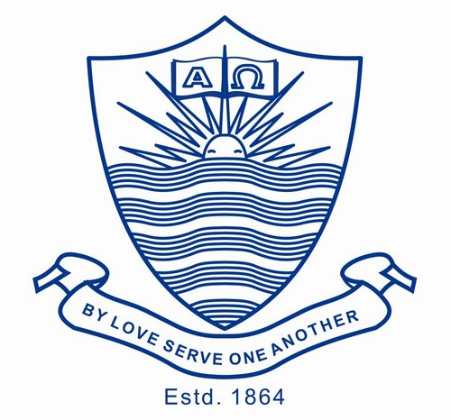

**Aliza Khokhar - 241546728**

**Nmap Basic Port Scans**

***TCP SYN Scan:***

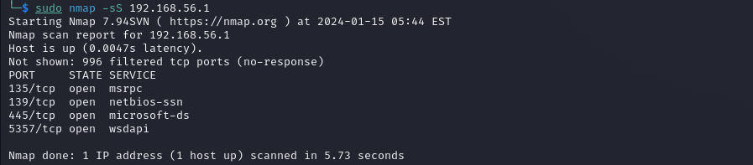

***TCP Connect Scan:***

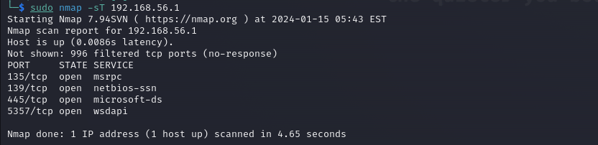

***UDP Scan:***

